江苏省测试卷讲解 Revision and check
溧阳市文化小学 王静芬
Step1: Pre-task
1.Learning aims
T: OK, boys and girls, good morning. This is a revision lesson. Today, We are going to play a brain storming game, check the examination answers, summary method of listening, reading and writing and practice more.
- Play a game
T: Today is Open Day. There are so many teachers in this classroom, ask and answer as many questions as possible with classmates within 30 seconds! OK?
T: Who wants to try?(两组) Listen carefully and count the questions.
T:How many questions does the first group ask?
How many questions does the second group ask?
T: So the second group is the winner! Clap your hands for them!

Step2:Listen and check（听一听）
1.Listening tips
T: Before listening, what should we do first?While listening, what should we do? After listening, what should we do?
S:（归纳总结）
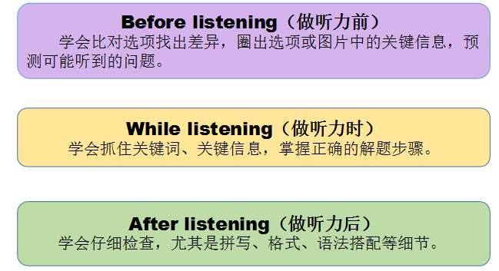
2.听力第6题讲解
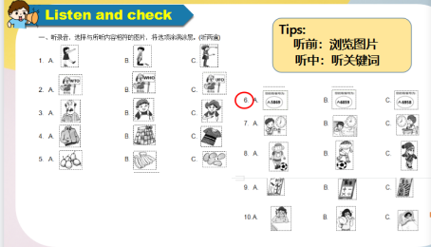
T：Look at this part, listen and choose, most of you did right, except S1. S1, stand up, please, what will you do next time?
S1：先把ABC三个选项默读一遍，写上关键不同的信息点，然后再认真听。
T：S1，please read these number. Then, listen this one again.(T再次放听力，S再做一遍)
3.听力第13题讲解
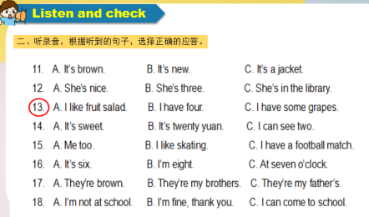
T：This part, listen and choose the correct answer. S2, you are right, how did you do it?
S2: (介绍成功经验)
T: Yes, read and circle the differences, and predict the questions. Who did wrong? Please hands up!
T: Some of you made mistakes, please listen again.
Ss 参照同学的成功经验，重新听一遍听力，完成选择。
4.听力第23题讲解
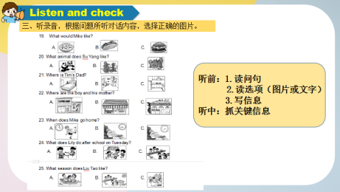
T：This part, listen and choose the correct picture. S3, you did right, can you tell me the method?
S:(介绍做题步骤)
T：Yes, and this is a little special, can you tell me the key information of these picture?
S：Play football是错误的选项
T：这是干扰项，我们要避免踩雷！Then delete A. What about B and C? Let’s listen.
S: I choose B. 因为回家的时间是4点40分。
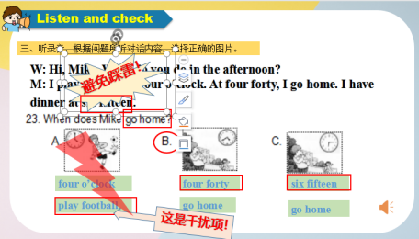

5.听力第五类
T：Look, this part is more difficult for you. Ten of classmates did right, wow, you are so clever. Can you share your ideas?
S:(介绍做题步骤或解题策略)
T：Yes, you should read the words and predict the main ideas. Please listen again.
Ss listen and check the answers.
6.Practice(听力课堂练习)
T: Can you use all these tips well? Let me check. Now take out your text paper. Listen and complete the table.(放录音)
Ss listen and check the answers.
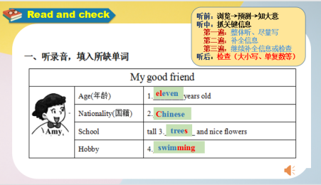

Step3:Read and check（读一读）
1.Reading tips
T: Before reading, what should we do first?While reading，what should we do? After reading, what should we do?
S:（归纳总结）

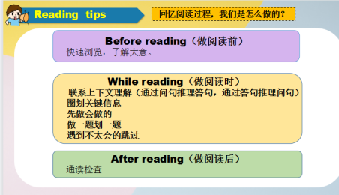
2.Practice(阅读课堂练习)
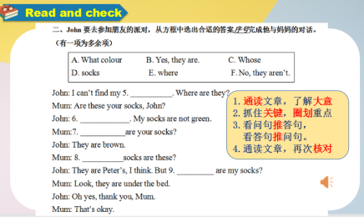
T：You all did well in this part, but what about this one? Take out your text paper. I will give you one minute to finish it. Let’s go.
T：Time is up, who wants to be a little teacher?
S4 上来介绍他的解题思路。
3.阅读理解A讲解
T：Look at this picture, what does content mean?
S: 目录
T：What do they mean?
S: 章节，页码。
T：When you read a book, you should read contents first.
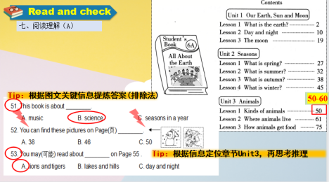
S介绍解题思路，解决51和53题，T此题的解题方法。
3.阅读理解B讲解
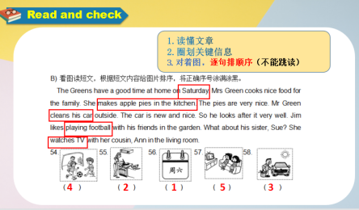
T：This part, it’s easy. How did you do it?
S 介绍做题的步骤
T：Yes, you should find out the key word, then match the pictures.
S 介绍每幅图相对应的关键词。
3.阅读理解C和D讲解（同上）
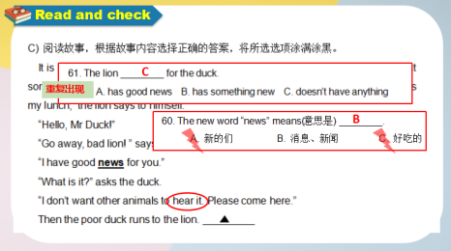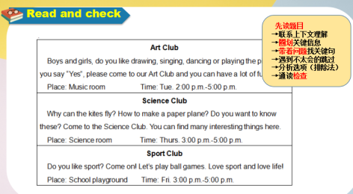
4.阅读理解诗歌
T: This is the poetry, what are the features of a poetry?
S: 短小、押韵...
T: Now let’s enjoy this beautiful poem together.(边读边完成61和67题)
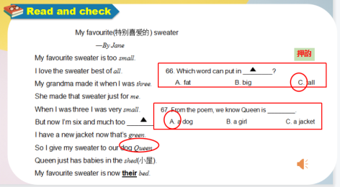

Step4:Write and check“写一写”
1.第八大题讲解
T: Now it’s time for writing. How to write?
S：拼写正确、书写规范、注意大小写、注意字间距。
T：Please pay attention to the capital letters. What words?还有哪些单词需要大写首字母？
S 归纳 read--think--write--check
T：What words need to be the capital letters?
S: 星期类、学科类等。
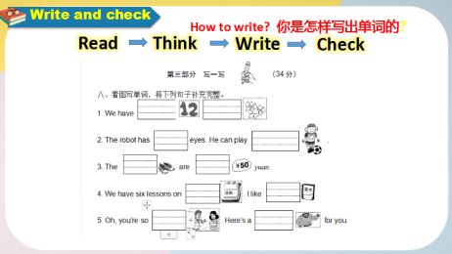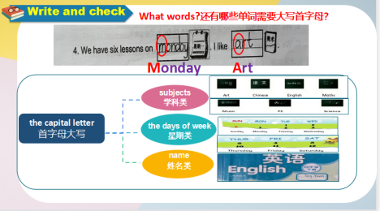
2.第九大题讲解
T：This part, you did a good job, but except S5 and S6. Can you help them correct the answers?
S分析两位同学的错误点，并改正。
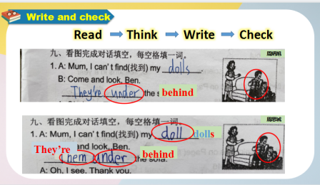

3.Practice
T: I think you should practice more, let us take out your text paper and do it.
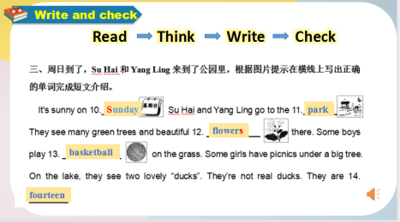
S 完成练习，分析并核对答案。
- 连词成句讲解
T：How did you do it?
S 分析解题过程，找出标点、词组等。
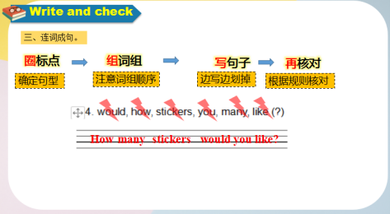
- 写作讲解
T：This is a composition. Before writing, what should we do first?While writing，what should we do? After writing, what should we do?
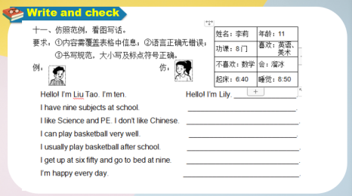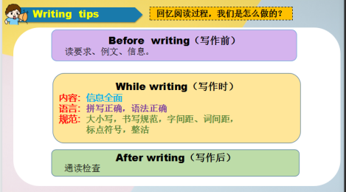
S分析做题步骤和注意事项。
Step5: Answer cards
T: How to use a answer cards?
S:介绍及完善使用答题卡的注意事项。
Step6: Homework
1.Write with the “Magic key” that you have learnt today.
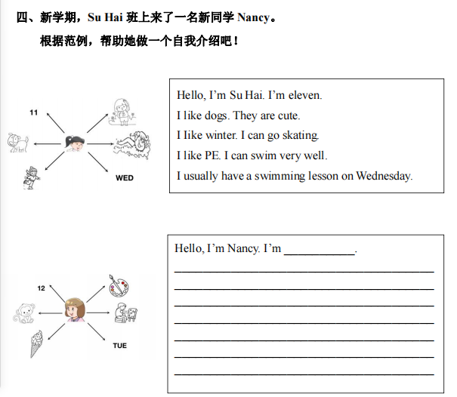
教学反思
本节公开课，我第一次尝试上了一节江苏省测试卷的讲解课，感受颇深。最深的一个感受就是习题课，应该更注重学生核心素养的培养，具体可分为以下三点：
1.深度思维的能力
我在试上时，带着学生拿着试卷对着PPT里的错误率较高的题目，进行归纳总结和讲解。但是通过多次磨课和文化小学教研团队的知道，我更关注了题目本身的内涵以及学生思维深度的提高。于是，在正式上的时候，我就让学生来总结题目的做题方法、策略或者步骤。此时的我，起到课堂的辅助作用，帮助学生分析题目，让其找出关键点，并引导学生打破习题局限，找到出题框架，学会深入思考，归纳总结解题方法。一个题目通过追问、观察、再做等步骤，让一个题目的讲评变成了一个知识脉络的梳理，学生的深度思维能力得到了激发和延展。
2.灵活思维的能力
我在试上时，为了方便归纳，把听、读、写三类题目总结成一个策略，让学生泛泛而谈。通过不断磨课和思考，我发现，在习题课上，我们更要关注学生的听课专注度以及解题过程的方法解读，要让学生开口讲，让学生能综合分析题目，并能举一反三，触类旁通。如我给学生提供的巩固作业，课堂的小练习，完成后，都是由学生来讲解分析做小老师。学生通过自己说和听教师讲完全是两个概念，自己说出来是知识内化后的输出，属于主动地组织语言表达，是有目的、有意识的行为。 而听教师说是被动的接受，相对来说，学生的思维活跃度更低。
3.批判思维的能力
这节课中，我把部分学生的“写一写”中的答题情况投在了PPT中，全班一起检查。 被选到的学生会异常紧张，其他学生也会很热心地一起纠错。讲完之后教师适当评价作业字迹和做题正确率，全班学生就更加清楚地知道做题要求了。随着“核心素养”这个概念的提出，学生的批判性思维能力更值得关注了，特别是有些题目没有标准答案，回答合理即可。看似简单，实则是更高要求的体现。所以，我们要适应这样的改变，并引导学生调动已学知识，作出合理解答。
实践出真知。上完本节课，我对试卷讲解的课堂有了更深刻的认识。要想小学练习课上得省时、省力、高效，作为教师，要不断思考、实践和反思，结合前人经验，教出自己的特色，提升学生核心素养。

